**CHAPTER 7 HOMEWORK**

**Q1. How do you fit SRS documentation into agile framework?**

**Ans.** Often, agile projects capture the requirements in the form of use cases, user stories, scenarios etc. The requirements are tended to be broken down into those forms which are currently being used. The only requirements that are well analyzed, validated, and estimated are those being worked on in the current iteration. The rest alteration in the requirements could be added, removed, or changed at any point in time.

For SRS, traditional plan-based SRS documents and formats are tailored. For this, it is recommended to keep a running list of what requirements are allocated to what area of the project. This document becomes a description of what the software is capable of at the completion of each iteration rather than a set of requirements that are to be built.

**Q2. Is it possible to use agile methodologies when the customer is not on site? If yes, how?**

**Ans.** The most effective and efficient way of communication is through face to face communication.It can be easily done via prototyping, using various interviewing techniques, etc. The main aim of agile methodologies is having more customer interactions, mostly at every step so that if there are any errors in the system, they could be identified easily and corrected on the same time. Moreover, communication is necessary. The method which we choose to communicate depends on the developer and the customer. They could take any form like interview, user story, scenarios and discussions done via mail or virtual chats.

**Q3. Why are agile methodologies generally not suitable for hardware based projects as compared to software based projects?**

**Ans.** Agile methodologies are not suitable for hardware based projects as compared to software based because:

* In hardware projects, once a system is in process it becomes difficult to alter it as the structure has started building. If changes are made in the beginning, one can still alter them but if they are introduced in the later stages it becomes difficult to do so as the hardware has already been built and to make changes, one needs to begin from the start.
* More revisions and versions mean more data to manage
* Cost for changing procedures and tools is very high
* Risk is very high
* Resources utilized can be wasted

**Q4. Why can it be difficult for agile methodologies to cover non-functional requirements?**

**Ans.** It can be difficult for agile methodologies to cover non-functional requirements because the requirements are not always apparent when dealing with customer. Customers often tend to just explain what they want rather than including the “how” i.e. the non-functional requirements of the system. There are times when the developer doesn’t ask for NFR as well from the customer as the system is continuously being built and changes are being done at every step. This is because requirements are being changed at every step and new details are being added.

In agile development, it becomes very difficult to cover the NFRs as one needs to pay attention to the functional requirements first. In the midst of functional requirements, NFRs are often ignored.

**Q5. Are there any problems in encapsulating requirements into user stories?**

**Ans.** User stories enable conversation that leads to extracting business and technical requirement. Applications are not collections of words but rather the implementation of those words. Words mean different things to different people. The same words can have different interpretation. That’s why, even with carefully crafted stories, it takes a lot for the designer to extract the exact requirements.

There are many different issues with encapsulating requirements like,

* One needs to make sure that the requirements are being portrayed properly and that the person at the receiving end understand them correctly
* Often, redundancy and contradiction of the requirements happen
* In the midst of telling the story, the crucial details about the system is missed
* Domain vocabulary issue arises
* One needs to make sure that there is same interpretation of the words that are used

**Q6. For pet store POS, generate a user story for customer purchase.**

**Ans.** 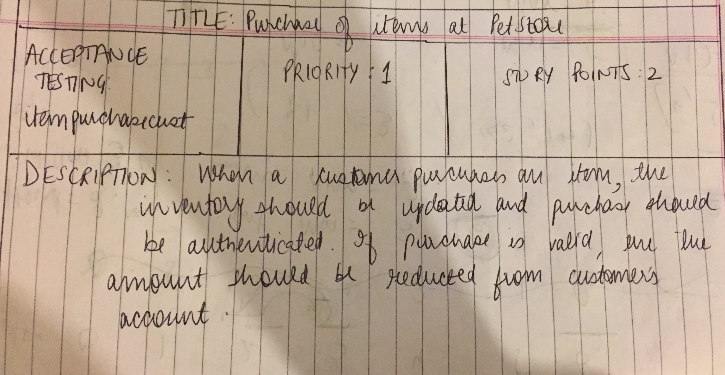

**Q7. For pet store POS, generate a use cases for various customer purchases.**

**Ans.** 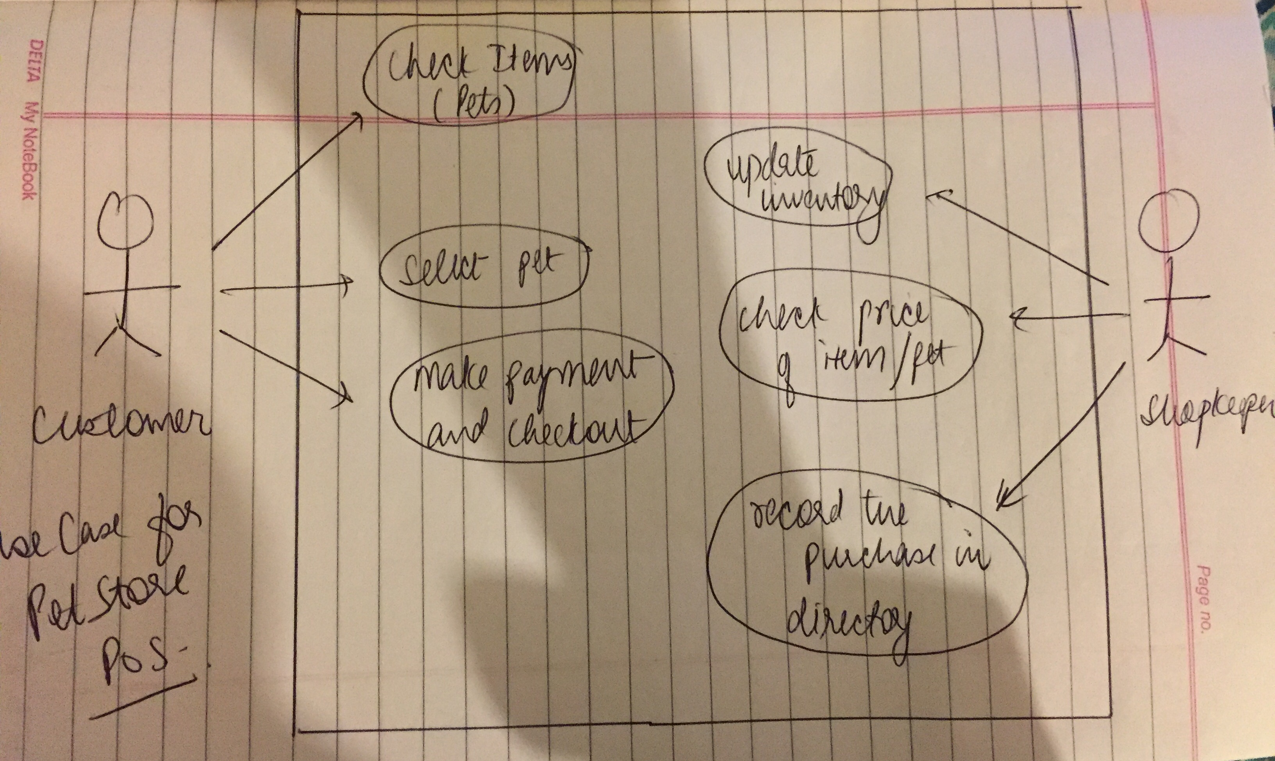

**Q8. For airport baggage handling system, generate a user story for dealing with baggage that is to be diverted to another flight.**

**Ans.** 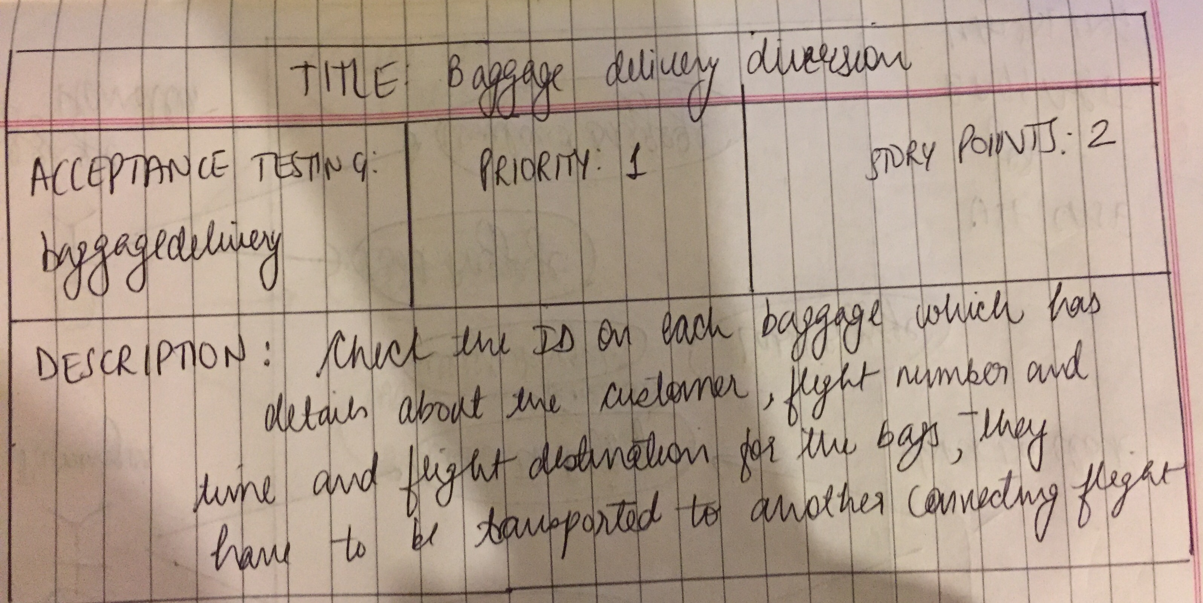

**Q9. For airport baggage handling system, generate use cases for dealing with baggage that is to be diverted to another flight.**

**Ans.** 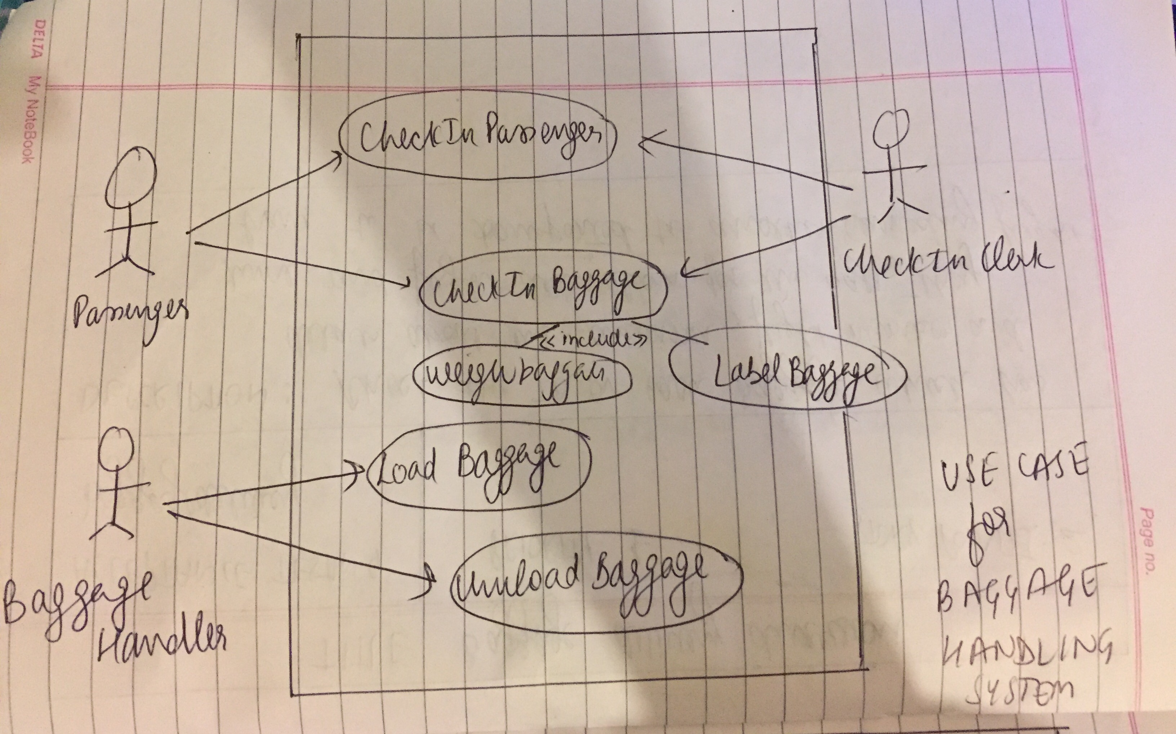

**Q10. There are a number of software tools, both commercial and open source, that can be used to manage the requirements activities of agile projects. Research these tools and prepare a product comparison matrix.**

**Ans.** There are a number of software tools for agile projects management. Some of the tools are as follows:

* **ActiveCollab:** It is the affordable solution for small businesses. It is easy to use, Its powerful document management, email-based communication features, priority etc have made it easier for projects managers who manage multiple projects at the same time.
* **Agilo for Scrum:** Used for a project that needs a powerful communication tool. It updates stakeholders on the project’s progress. It also offers tools to make sure that all team members are aware of the latest updates automatically.
* **Atlassian Jira:** Teams can use this product as either a self-hosted or cloud-based solution. Project managers can make customized workflows, visualize QA issues, and keep in constant communication.
* **Pivotal Tracker:** Specially created to assist web and mobile developers. It supports multiple projects, burndown charts, messaging between users, project-based tasks, and user stories. Easy to use.
* **Sprintground:** Users can easily parse out projects, versions, and releases. It has a framework that encourages developers to look at feature requests, suggestions, and questions in addition to offering traditional bug tracking functionality.
* **Targetprocess:** It emphasizes on data visualization. The software offers pre-prepared solutions for each person on the project team. Scrum Master can customize development flow, for an IT manager to get his tickets straight, and for a product owner to emphasize which features are most important for the company or client.
* **VersionOne:** It has intuitive user interface, ability to customize for any style, easy-to-understand reporting features. On can keep up with their teammates’ and personal tasks right from the dashboard.
* **OSRMT:** This is an open source requirements management tool that works in a “client-server” model. This is no longer active.
* **aNimble:** This open source tool that uses “client-server” model, but will soon release the web-based version.
* **rmtoo:** It does not offer GUI for the system.

|  |  |  |  |  |  |  |  |
| --- | --- | --- | --- | --- | --- | --- | --- |
| Technologies🡪 | **ActiveCollab** | **Agilo for Scrum** | **Atlassian Jira** | **Pivotal Tracker** | **Sprint ground** | **Target process** | **Version One** |
| Pros | Intuitive, outstanding support | Responsive support team | Mobile app, strong backlog management, and lots of add-ons so project managers can customize the software to their team’s needs. | Supports cross-functional teams, and free for individuals and public projects | Encourages customer-driven product development | Unique design that’s great for enterprise companies | Easy to use, great integration systems |
| Cons | Timeline and column views for tasks | No ability to host more than one project | Switching between apps can be a pain. | System is difficult to customize | File storage is limited | The company charges $150 per hour for training on how to use their own product | The free version is very limited. |
| Cost | Self-hosted at $499 | €10 a month for unlimited users, one team, one project, | Starts at $10/mo for 10 users | Free for three users, 2GB of storage, and two private projects | Free for three users, two projects, and 50MB of file storage. | Free for up to 1,000 entities | Free for one project and one team. |

**Citations:** [**http://blog.capterra.com/agile-project-management-software/**](http://blog.capterra.com/agile-project-management-software/)